What is Health & Safety Management System?



An **Health & Safety management system** (**H&SMS**) is "a system and database which integrates procedures and processes for training of personnel, monitoring, summarizing, and reporting of specialized Health & Safety performance Hazards to internal and external stakeholders of a firm".The most widely used standard on which an H&SMS is based is International Organization for Standardization (ISO) 45001. An Health & Safety management Hazards system is an Hazards solution for tracking Health & Safety data for a company as part of their overall Health & Safety management system.  The H&SMS by itself, does not dictate a level of Health & Safety performance that must be achieved; each organization's H&SMS is tailored to the its own individual objectives and targets.

Where & how can Health & Safety Management System be applied?

For **Health & Safety Management System** (**H&SMS**), be applied to any organization, irrespective of size or industry sector. H&SMS principle approach has following basic principles & strategies in place:

|  |  |
| --- | --- |
| Principles – QMS Principles may be considered to maintain  H&SMS apart from aspect & Impact | Strategies |
| Visible and active commitment to health and safety from Top level as Top Priority;Effective management structure with H&S as Top priority;Clear downward & upward communication systems;Integration of Health & Safety Management with Business decisions on Priority;Workers involvement in resolving Health & Safety challengesAccessing & following competent advice;Believe and understand that in H&SMS, the impact changes after treatment of the risk, apparat from reducing the likelihood of occurrence; | * Focus on the scope & context applicability of H&SMS; * Identify Hazards & Solution & their clarity of clear understanding of importance of measures to avoid the same – at every level in the organization; * Define Risk Assessment to identify Risk Impact of each Hazard w.r.t Time & Loss; * Perform Risk Evaluation (Impact Level) on current controls and after new controls; * Focus the Health & Safety Controls on the Hazard’s Vulnerability causing the Impacts; * Understand and approve the Residual Risks & Implement the selected controls & monitor for performance |

What can make Health & Safety Management System journey successful?

To implement & get maximum benefited from H&SMS, there has to be ***baseline mindset principles***, in which every member of the organization (including Top Management) should believe in:

|  |  |
| --- | --- |
| Mind Set for H&SMS | Benefits of H&SMS |
| * Clear understanding the importance of Hazards and its legitimate measures to avoid such situations; * Open mind to adopt culture for new understanding & learning concepts, technology and its vulnerabilities of the relevant Hazards, in more precise manner; * Complete Transparency in understanding, implementing changes, if need be, at appropriate time; * **Always believe that, what we know today is not enough and not the end**; * Always believe in and practice team work, commitment to improve and believe in that: * **Any System to be in such a manner that people depend on System, & not the other way round**”; * Ask self-question all the time - “Am I interpreting the requirements of H&SMS Standard in current manner?; * Importance has to be given to documentation with Criteria inbuilt into it for internal transparency; * **Believe in building up Process KEDB (Known Error Data Base) – and update in disciplined manner and ensure that this is accessible to every one** | * Improved health and safety performance; * Reduced cost associated with accidents and incidents; * Improved staff relations and moral; * Improve business efficiency; * Improved public image and PR; * Lower insurance premiums; * Easier access to existing regulations and compliance; * Encourages contractors and suppliers to establish their own H&SMS; * Facilitates e-reporting to federal, state and provincial government Health & Safety agencies through direct upload; * **Building Confidence into all the Interested parties that Health is intact;** * **Employment Retention** |

What is Annexure L?

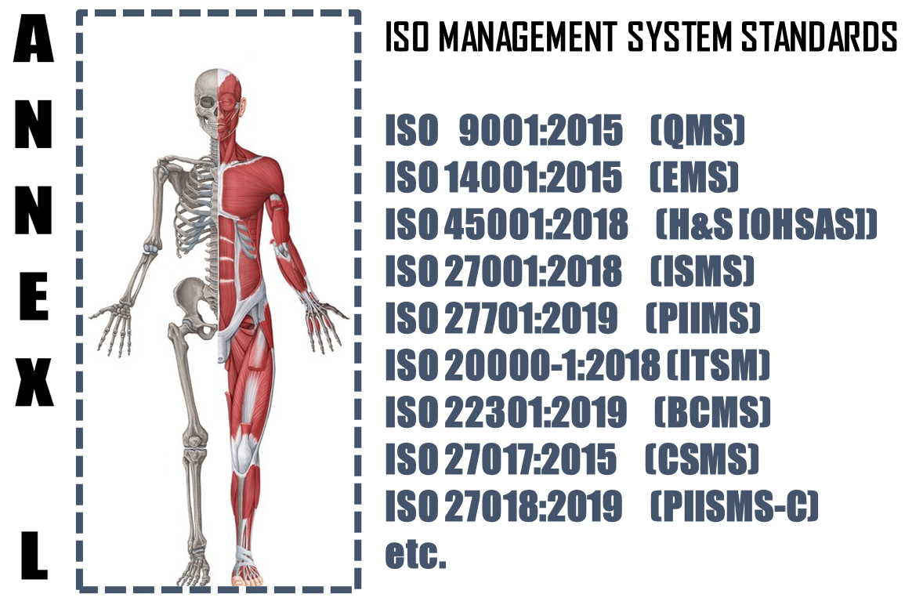

The **Annex L** (now renamed as Annex L in the 2019th edition from Annex SL) is a section of the ISO/IEC Directives part 1 that prescribes how ISO Management System Standard (MSS) standards should be written. The aim of Annex L is to enhance the consistency and alignment of MSS by providing a unifying and agreed-upon high level structure, identical core text and common terms and core definitions. The aim being that all ISO Type A MSS (and B where appropriate) are aligned and the compatibility of these standards is enhanced.

So in short we can say that Annex L is the Skeleton of ISO Management SystH&SMS and all standards are now aligned as per Annex L and all the common elements terms and definitions have also been standardized. This has been done to bring in Standard in the Structure, which was not the case in the past, though the intention was the same. So we can say, out of Intent and Content of MS, Content has undergone a change, in the form of Anne L.

What to do in Implementing Health & Safety Management System?

Based on the Scope and Context, following activities have to be performed in logical sequence. These guidelines given below are only basic milestones and a lot of activities may have to be streamlined as per the standard, based on Scope & Context.

|  |  |  |  |  |
| --- | --- | --- | --- | --- |
| **Step #** | **Requirement of H&SMS** | **What needs to be done** | **In what way IRCBO can contribute** | **Tools Recommended** |
| 1 | Defining & Documentation | * Defining & Documenting Scope (Technical [Product/Services] and Territorial Scope (# Locations) where the MS is needed. The Org. Management decides the specific scope in line with Applicable regulations * Defining the External & Interested Parties, their business relationship with Org. (in relevance to scope), Identification of critical processes, Hazards . * All relevant policies and procedures for delivery of products and services, as per scope & context - these procedures or process documents for each interested party activities shall include acceptance criteria as well – including Design of Product/Service Processes; | IRCBO’s Qualified & Experienced consultants can help you in designing, defining, Implementing, monitoring and Improving the MS.  Note: Our contracts can also be associated after Certification for Maintenance of Management System through our digitized tool contributions – aim is to make any MS a plug and play for most effective Controls & Complying (including Legal Compliances) | IRCBO Tool Kit which includes all solutions for Implementation and backed up by IRCBO Designed Software in cloud for :   * Online training   (including  Induction for new employees, awareness & unlimited Internal Auditor Training & Qualification   * Online Internal Auditing Software – this also includes tracking of corrective actions |
| 2 | Implementation | * Implementing all policies and procedures as per H&SMS defined system; * Assigning and plying Responsibilities and Authorities in more transparent manner; * Participating in Risk Mechanism and approving Residual Risk and H&SMS Incident investigations; * Focusing on Increasing Competency, * Maintaining good discipline in demonstrating Leadership and aiming for improvements through Management Review platforms; |
| 3 | Periodical Review | * Monitoring, measuring and performing Analysis to ensure * Considering Internal Audit Findings seriously for Timely Corrective Actions in effective manner and take decisions to improve in Management Reviews |
| 4 | Continual Improvement | Implement all actions of Management Review and aim for Continual Improvement – remember Improvement & Continual Improvement are different Concepts |